1. 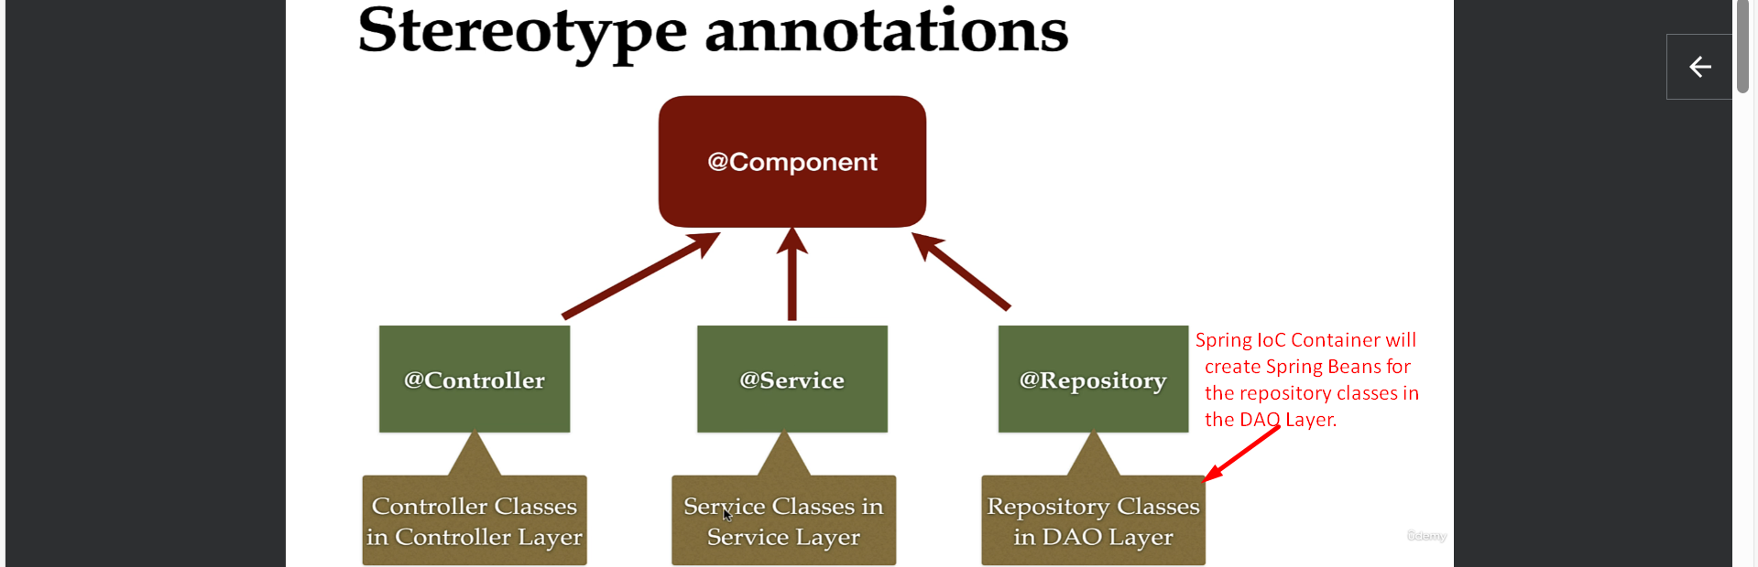  
   @Component is the main annotation and all other annotations are derived from the @Component.
2. Let’s do some hands-on.  
   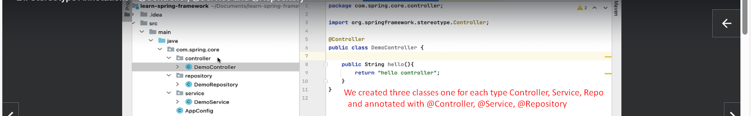  
      
     
   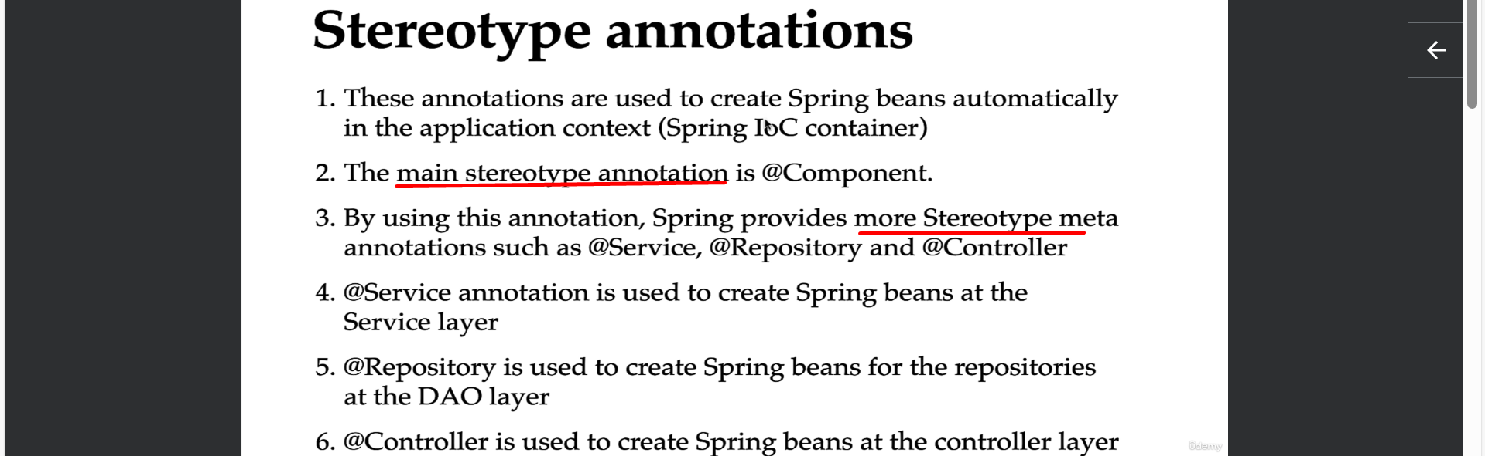
3. Next, let us see how to retrieve these Spring Beans from Spring IoC Container. 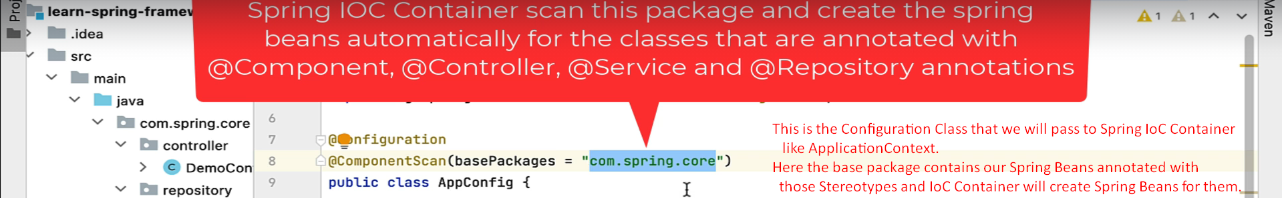
4. 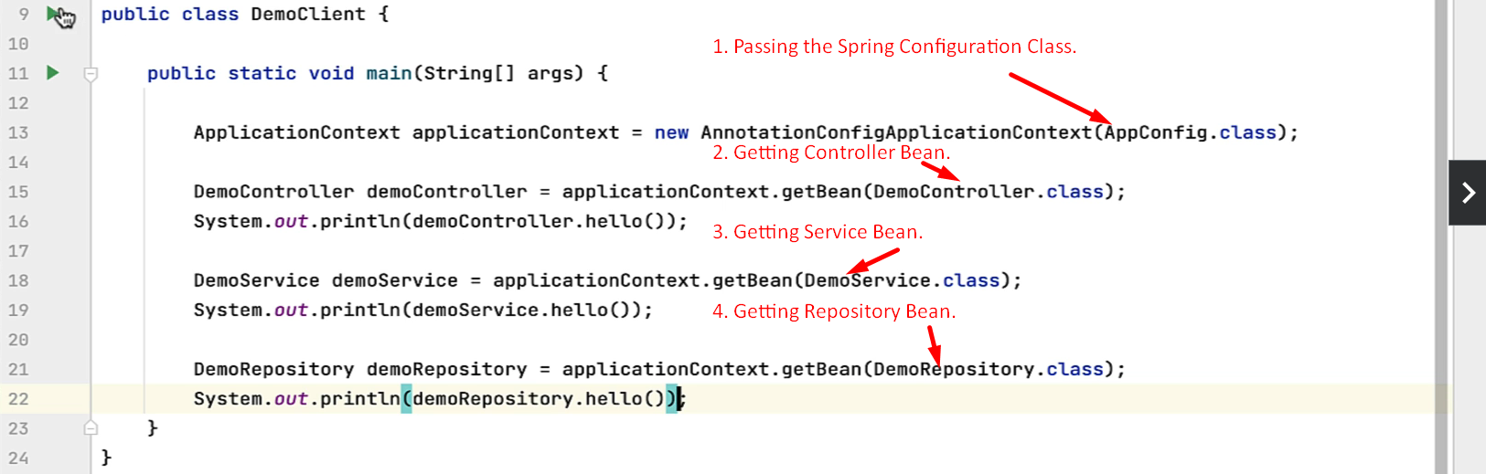  
     
   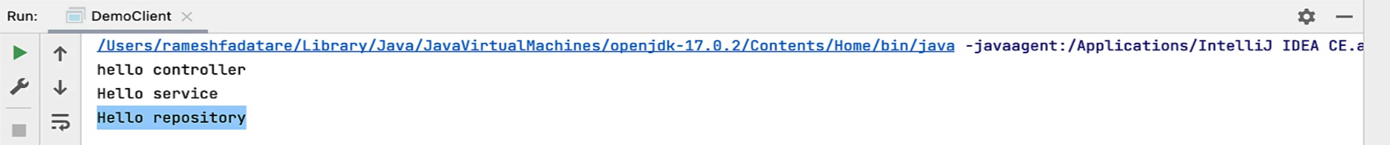
5. So, like this, we can use these StereoType Anntations to create Spring Beans in Spring IoC Container.